🏥 Hospital Patient Feedback & Improvement Dashboard
📌 Project Overview
The Hospital Patient Feedback & Improvement Dashboard is a Business Analysis project designed to transform manual patient feedback collection into a centralized, digital, and data-driven system.
The primary objective of this initiative is to:
- Improve service quality monitoring
- Increase departmental accountability
- Enable data-driven strategic decision-making
- Enhance overall patient experience
This project demonstrates end-to-end Business Analysis activities including requirement gathering, stakeholder analysis, documentation, process modeling, data analysis, and dashboard reporting.

🎯 Business Problem
NMMS Hospital was collecting patient feedback manually, which resulted in:
- Lack of centralized data storage
- Delayed identification of service gaps
- Limited visibility into department-wise performance
- No structured mechanism to track improvement actions
This created challenges in proactive decision-making and continuous service improvement.

💡 Proposed Solution
To address these challenges, a centralized digital Patient Feedback & Improvement Dashboard was designed.
The solution enables:
- Structured digital feedback submission
- Automated satisfaction score calculation
- Department-level performance tracking
- Real-time dashboard visualization
- Identification of service gaps
- Tracking corrective and improvement actions

🛠 Tools & Deliverables
1️⃣ Confluence – Business Documentation
- 📄 Business Requirements Document (BRD)
- 📄 Functional Requirements Document (FRD)
- 📄 Patient Feedback Submission & Satisfaction Score Criteria
- 📄 UAT Scenarios with Expected Results
🔗 Documentation Link:
https://nareshboltnaresh.atlassian.net/wiki/spaces/~7120207865ab9607e740eb8860f080adec9706/folder/786433

2️⃣ Lucidchart – Process Flow Diagram
- End-to-end feedback collection and processing workflow
- Stakeholder interaction flow
- System validation flow
🔗 Flowchart Link:
https://lucid.app/lucidchart/a053426d-f006-406f-8c62-18e0b4a3b8de/edit

3️⃣ Jira – User Stories & Backlog Management
- Epics and user stories
- Acceptance criteria
- Requirement traceability
- Agile backlog prioritization
🔗 Jira Project Link:
https://nethrabharathy.atlassian.net/jira/software/projects/KAN/list

4️⃣ As-Is to To-Be Analysis
This section illustrates the transition from the current manual feedback process (As-Is state) to the proposed centralized digital dashboard solution (To-Be state). It highlights the identified gaps, process inefficiencies, and the strategic improvements designed to bridge those gaps and enhance service quality, transparency, and decision-making within the hospital.
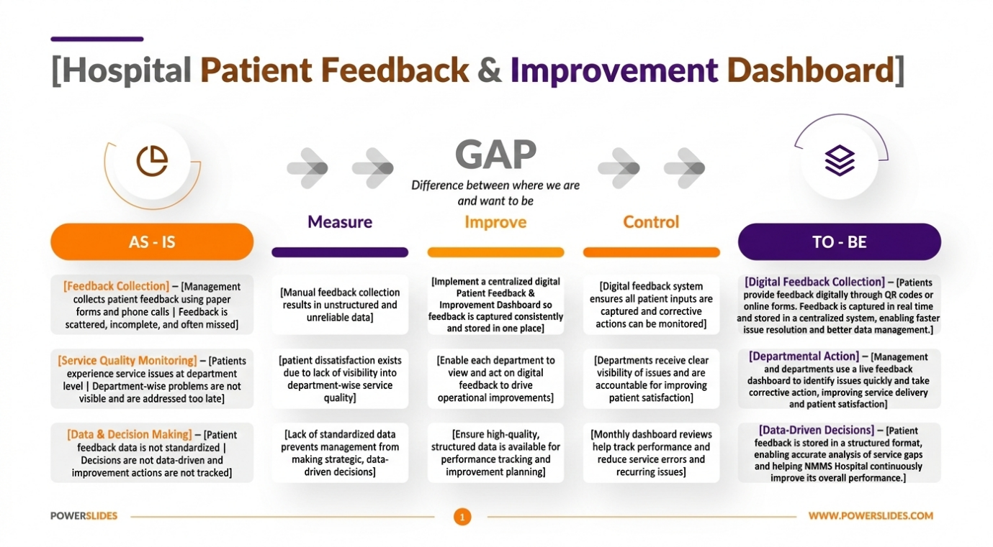
5️⃣ Excel – Data & Stakeholder Analysis
- Stakeholder Register
- Department-level performance analysis
🔗 Excel File Link:
https://1drv.ms/x/c/f08605bedcd85afa/IQCTlYOQsfjDQ7BJ7oITWX0oATZ0YGXXL9iRaIP-k-2ljJM

6️⃣ SQL Server Management Studio (SSMS)
- Database design
- Data cleaning and transformation
- Aggregation queries
- KPI calculation queries
🔗 SQL Queries Repository:
https://github.com/Nethrabharathy/Hospital-Patient-Feedback-Improvement-Dashboard/blob/main/Business%20documents/database_queries.sql

7️⃣ Power BI – Interactive Dashboard
- Overall satisfaction score
- Department-wise performance metrics
- Feedback trends
- Service gap identification
- Improvement tracking metrics
Interactive dashboard built to support executive decision-making.
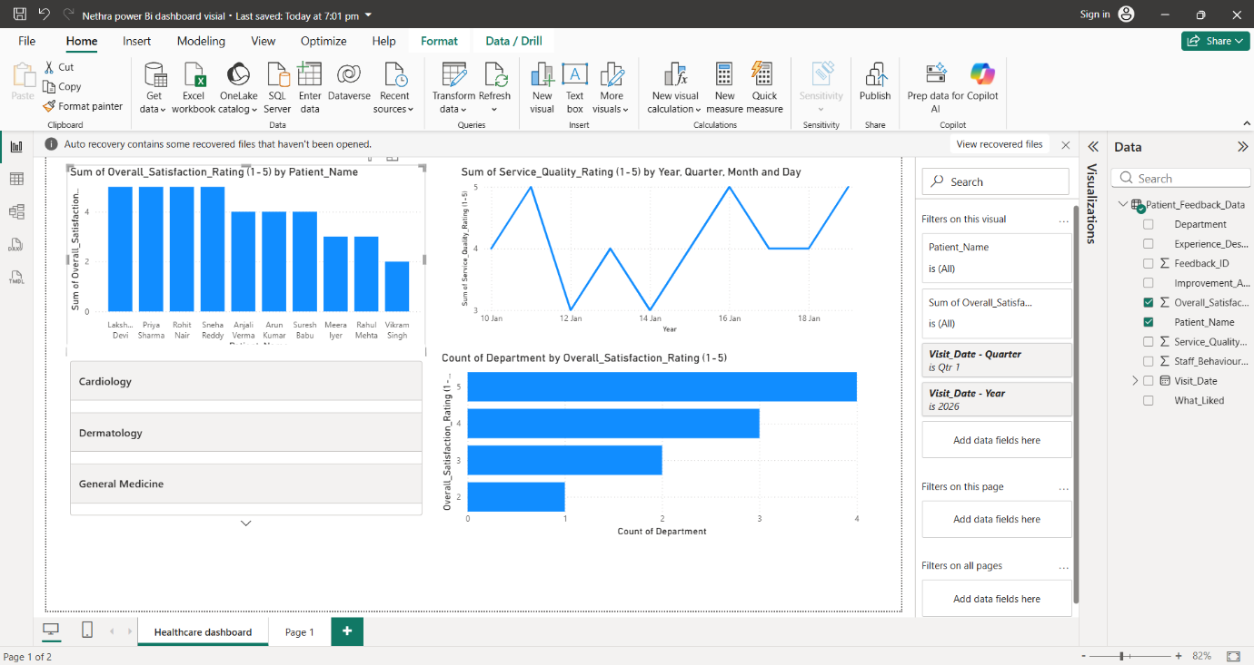

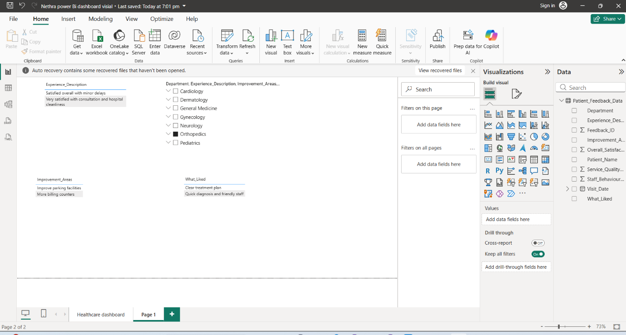

8️⃣ Key Insights Generated
- Identification of low-performing departments
- Trends in patient satisfaction over time
- Common complaint categories
- Actionable improvement areas
- Data-driven recommendations for hospital management

9️⃣ 🖥 System Interface
NMMI Hospital Patient Feedback Dashboard – User Interface Overview
Includes structured feedback submission screen and performance tracking dashboard.
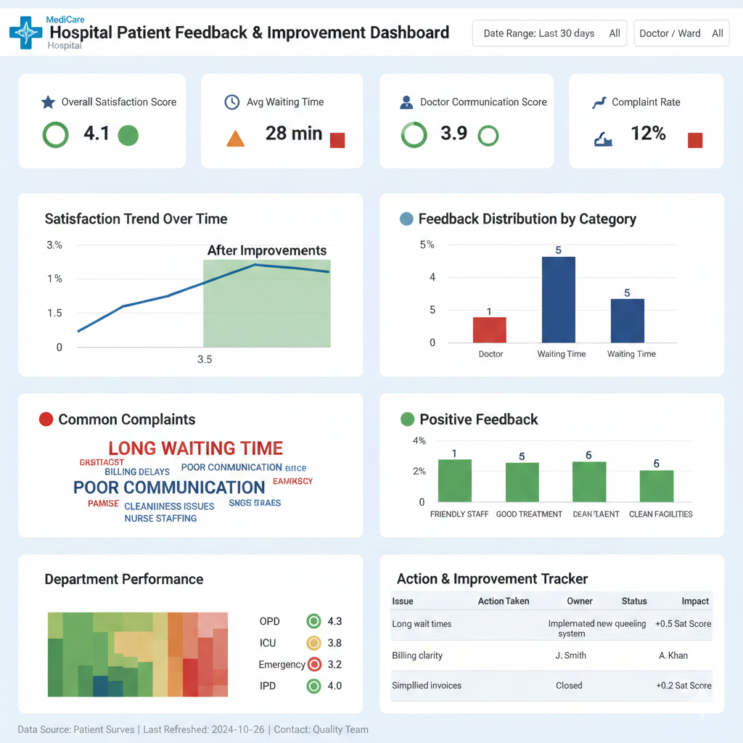

🔟 📈 Business Impact
- Improved transparency in service quality
- Faster issue identification
- Structured improvement tracking
- Data-driven culture within hospital management
- Enhanced patient experience

👩‍💼 Role & Responsibilities
As a Business Analyst, I was responsible for:
- Stakeholder identification and analysis
- Requirement elicitation and documentation (BRD & FRD)
- Process flow modeling
- User story creation in Jira
- Data analysis using SQL & Excel
- Dashboard design in Power BI
- UAT scenario creation

👤 Author
Naresh
Business Analysis Project
Hospital Process Improvement Initiative

